**DAILY ASSESSMENT REPORT**

|  |  |  |
| --- | --- | --- |
| **DATE** | **22/05/2020** | NAME **K GAURAV SHET** |
| **COURSE** | TCSiON | USN **4AL18EC023** |
| **TOPIC** | **1.Artificial intelligence part 1**  **2.AI part 2**  **3.Final asessment** | **SEM 4th sem.A sec**  **sections** |
| **Github Repository** | **Gaurav-shet** |  |

**FORENOON SESSION DETAILS**

**Image of session**

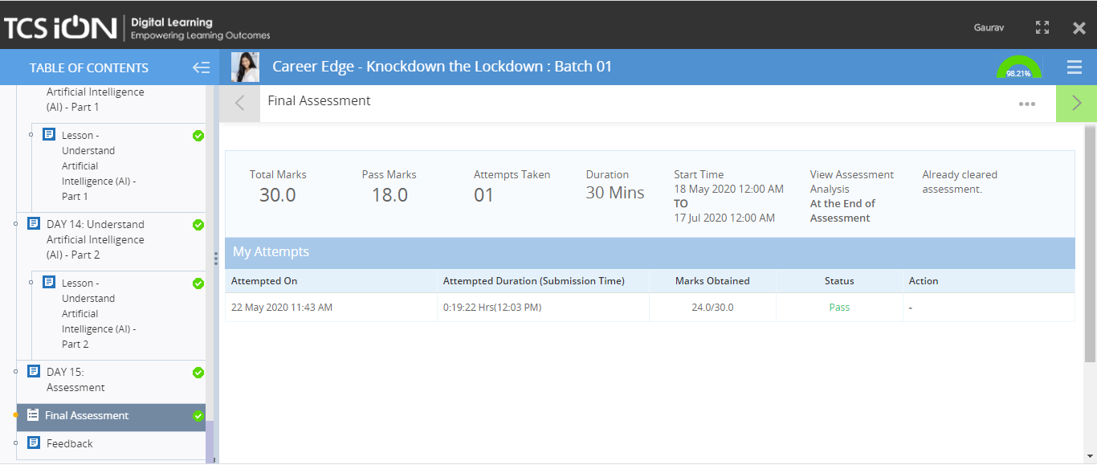

**TOPIC 1:Day 13. Artificial intelligence part 1**

**In this module we learnt**

**Need and development of AI**

**TOPIC 2:Day 11: Artificial intelligence part 2**

**In this topic we learnt**

**More about AI**

**Topic 3: Final assessment**

**Quiz**



**AFTERNOON SESSION DETAILS**

|  |  |  |  |
| --- | --- | --- | --- |
| **DATE** | **22/05/2020** | **Name** | **K Gaurav shet** |
| **COURSE** | **Python for machine learning by great learning and morsh python** | **USN** | **4al18ec023** |
| **Topics** | **1.Class and objects**  **2.Functions and user defined function**  **3.data frames** | **Sem and section** | **4th sem.A SEC ECE** |
| **Github repository** | **Gaurav-shet** |  |  |

**Images and report of the session**

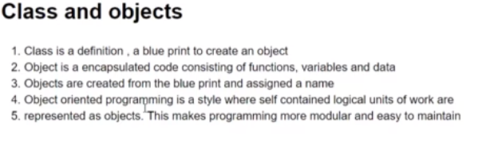

**Combining Data frames:**

**There are three major units used in combine dataframes,’**

**1.Concat**

**2.Join**

**3.Merge**